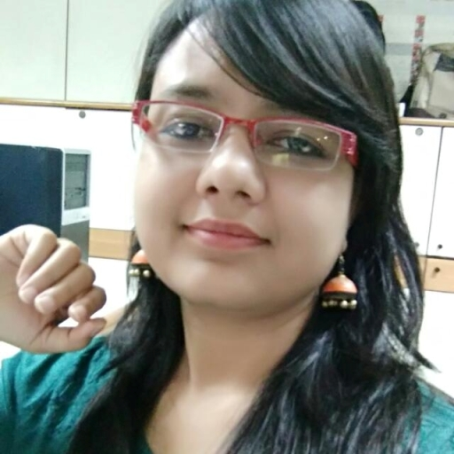

ARPANA KUMUD
A-98, Flat no D-2,
North Vinod Nagar
Delhi  92
Tel : + 91-9013661316, + 91-8527526226
E-Mail Id : arpanakumud03@gmail.com

PROFILE
To Act as Catalyst to the success of the organization and keep an open mind to facilitate continuous learning and keep a participative role in helping organization to achieve its goals and improving its core competency.

- CAREER OBJECTIVE
- WORK EXPERIENCE
Currently working with PTI largest news agency in Asia, from November, 2010, as a journalist.
Its a desk job where I get to handle
- Foreign Desk
- PMs foreign visits
- Political stories
- Edited the stories of 2014 General Election and various state elections
- Besides, I keep doing qualitative stories as a reporter when I get time from
my regular desk job.
CURRENT

Nov 2008 to
Oct 2010
Worked with HT Media Limited as a Correspondent for 2 yrs
During this period I mainly covered
- Crime
- Health
- Education
- General and State elections

Jan 2006 to
Sept 2007
Worked as an Assistant Director for an yr with SOUTH VIEW PRODUCTIONS,
a leading production company specialised in making documentaries on Social
cause where :
I got an opportunity to work on a prestigious project undertaken by the Ministry of
Women and Child Development on the socially relevant issue of “ Female Sex
Ratio ” in Haryana

Worked with Aha! Zindagi, a Dainik Bhaskar Group magazine for 6 months
Masters in Mass communications : Guru Jambheshwar University, Hisar
- EDUCATION
- COMPUTER KNOWLEDGE :

Basic Knowledge of M.S. Office & other General Purpose Software, E-Communication skills

- AREAS OF INTEREST

- Corporate Communication
- Reporting, News Writing and Editing
- PR & Advertising
- H R & Admin.
- Business Development

- STRENGTHS:

- Self Motivating and hard working, taking self initiative in all assignments
- Able to handle the pressure situation
- Analytical and Comprehensive approach in solving problems and challenges
- Good Communication and Writing Skills esp. in English
- Honest and dedicated to work
- Wide contacts in media fraternity, which is helpful in Public Relation job
- Good Current Affairs knowledge, special interest in economic & finance related topics.

- TRAINING:

- Done one month training with HINDUSTAN (The Hindi Daily of HT House)

- Worked as the Editor of Departmental Hindi News Paper AKSH during graduation

- Worked as the Editor for REFLECTIONS (Departmental English newspaper), and
MEDIA VIBES (Departmental magazine)
- Associated with MAHATA MEDIA SOLUTIONS as an Assistant Video editor.

PG in Hindi Journalism : University of Delhi, South Campus

Bachelor in Mass Com : Guru Jambheshwar University, Hisar.

Senior Secondary : RS Senior Secondary School, Delhi
Secondary : PM Girls High School, Brindawan Ashram (Bihar Board)

References of documents available on request.
- HOBBIES:

- Interest in Quiz contests & Debates
- Interest in reading and writing diary
- Playing Chess, Carom and Badminton
- Listening to light, soulful music especially the golden music from yesteryears
- Cooking and traveling
- PERSONAL INFORMATION :

Fathers Name : Shree. S.S. Singh
DOB : 01.01.1988
Marital Status : Unmarried
- DECLARATION :

I declare that all the above information is true to the best of my knowledge and belief.

Place : New Delhi Signature

Date : 29.11.2017 (Arpana Kumud)

